**Department of Computer Science**

**Forman Christian College University**

**COMP360: Introduction to AI**

**Fall 2021**



|  |  |  |  |
| --- | --- | --- | --- |
| **Task 1 (2)** | **Task 2 (9)** | **Task 3 (9)** | **Total (20)** |
|  |  |  |  |

**Lab 2: BFS and DFS Implementations and Comparisons**

This lab is aimed to give you the opportunity to practice and observe the practical implementation of Breadth-First-Search (FBS) and Depth-First-Search (DFS).

**Important Instructions:**

* Lab Manual is self explanatory so read through this lab manual before starting the lab.
* You can use any of the **Programming Language** that you think works better for you in this Lab.
* You can get help from you friend **Google** But remember Copy and Pasting of the code is prohibited and is not a good practice.
* Every question asked in the viva will have marks, So make sure you understand what you write and should be able to explain the code.

**Expected Deliverable:**

* **The Code File:** File having the implementations of BFS and DFS
* **This Word File:** The same document file (Lab manual) you have the observed results that you will be filling in the following tasks.

**Submission:**

***Zip your deliverable files and with your “Roll_Name_Lab2.zip” and submit on moodle***

**Experimental Tasks:**

You need to perform the following tasks in order to qualify this Lab.

**Task 1:** Observe the following **Tree.** Consider that node having “**1”** is the root node.

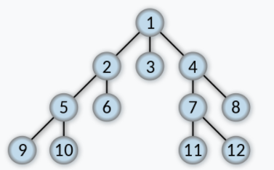

**Task 2:** Write the code for **BFS,** try the above tree node’s numbers as inputsand write down the results you observed.

**Task 3:** Write the code for **DFS,** Try the above tree node’s numbers as inputs and write down the results you observed.

***Note: This is an individual Lab and Groups are not allowed.***

**Code Format:**

Follow the following Code format.

Make Functions of BFS and DFS.

Make a Main test function to call the above functions.

Use any of the programming language you feel comfortable with. (Java, Python, C++ or anyother etc)

*def BFS():*

*#code*

*#code*

*#code*

*def DFS():*

*#code*

*#code*

*#code*

*__main__ :*

*BFS()*

*DFS()*